**Problem Statement**

The drawback in the early OCR systems is that they only have the capability to convert and recognize only the documents of English or a specific language only. That is, the older 4 OCR system is uni-lingual.

**Architecture**

The Architecture of the optical character recognition system on a grid infrastructure consists of the three main components. They are:- Scanner ,OCR Hardware or Software , Output Interface.

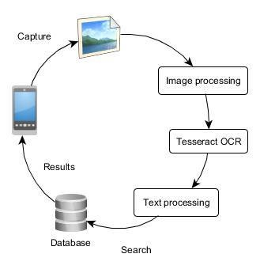

**PROPOSED SYSTEM** :- Our proposed system is OCR on a grid infrastructure which is a character recognition system that supports recognition of the characters of multiple languages. This feature is what we call grid infrastructure which eliminates the problem of heterogeneous character recognition and supports multiple functionalities to be performed on the document. The multiple functionalities include editing and searching too where as the existing system supports only editing of the document. In this context, Grid infrastructure means the infrastructure that supports group of specific set of languages. Thus OCR on a grid infrastructure is multi-lingual.

**BENEFIT OF PROPOSED SYSTEM** :- The benefit of proposed system that overcomes the drawback of the existing system is that it supports multiple functionalities such as editing and searching. It also adds benefit by providing heterogeneous characters recognition.

**INTENDED AUDIENCE AND READING SUGGESTIONS :-**  In this section, we identify the audience who are interested with the product and are involved in the implementation of the product either directly or indirectly. As from our research, the OCR system is mainly useful in R&D at various scientific organizations, in governmental institutes and in large business organizations, we identify the following as various interested audience in implementing OCR system:- The scientists, the research scholars and the research fellows in telecommunication institutions are interested in using OCR system for processing the word document that contains base paper for their research. The Librarian to manage the information contents of the older books in building virtual digital library requires use of OCR system. Various sites that vendor e-books have a huge requirement of this OCR system in order to scan all the books in to electronic format and thus make money. The Amazon book world is largely using this concept to build their digital libraries. Now we present the reading suggestions for the users or clients through which the user can better understand the various phases of the product. These suggestions may be effective and useful for the beginners of the product rather than the regular users such as research scholars, librarians and administrators of various web-sites. With these suggestions, the user need not waste his time in scrolling the documents up and down, browsing through the web, visiting libraries in search of different books and … The following are the various reading suggestions that the user can follow in-order to completely understand about our product and to save time:- It would help you if you start with Wikipedia.com. It lets you know the basic concept of every keyword you require. First learn from it what is OCR? And how does it work based on a Grid infrastructure? . Now you can proceed your further reading with the introduction of our product we provided in our documentation. From these two steps you completely get an in depth idea of the use of our product and several processes involved in it. The more you need is the implementation of the product. For this you can visit FreeOCR.com where you can view how the sample OCR works and you can try it.